**Summary - Complete Dataset using internal calibration**

**Step 1: Test whether offsets are different depending on Phantom Type only!**

*(I want to primarily demonstrate that adopting an Expanded phantom is better)*

Mean weight offsets are significantly different between PhantomTypes used

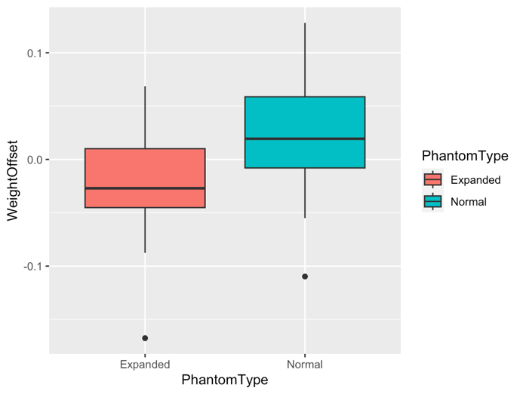

Removing outliers

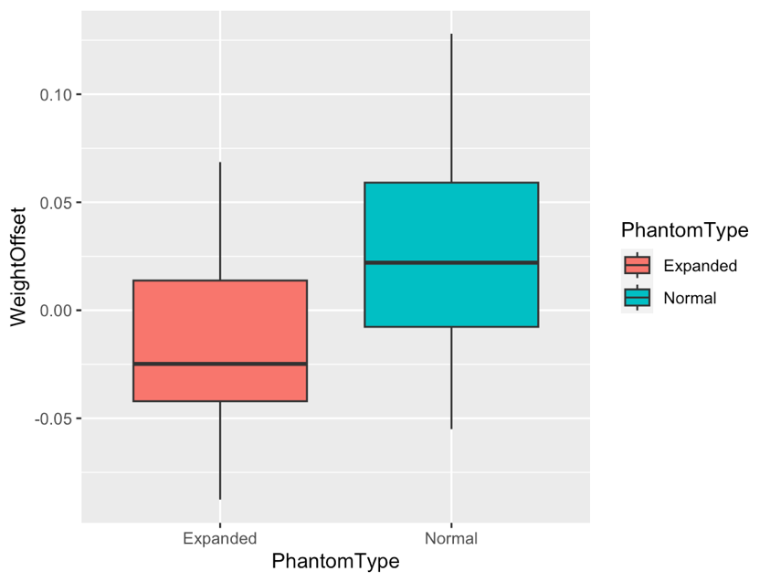

ANOVA with Outliers removed

We get an even stronger significant difference.

Distribution looks normal

Analysing contrasts

Contrast data summarized in a DotPlot with mean and standard error  
  
Mean WeightOffset for Expanded phantom is -0.0196

Mean WeightOffset for Normal phantom is +0.0294

Confidence Interval range for Expanded Phantom is negative and equal to - **0.03924** (narrower)

Confidence Interval range for Normal Phantom is positive and equal to **0.05892** (wider)

**Take home message:**

There is strong evidence to suggest that mean weight offsets are significantly different between PhantomTypes when adopting internal calibration (p <.0001). The absolute mean weight offset is smaller and has a narrower confidence interval when using the Expanded Phantom (1.9%±3%), compared to Normal Phantom (2.9%±5). This indicates that an Expanded Phantom is better suited to constrain a varied array of grey-scale density distributions coming from different coral colonies.

Further, scans done using an Expanded Phantom usually produce negative offsets (i.e., underestimated coral weights), whereas the same corals calibrated using a Normal Phantom tend to overshoot weights easily, thus resulting in more cases of overestimation in coral weights (i.e., positive offsets). Nonetheless, it is still possible to work with scans where density distributions were calibrated based on Normal Phantom as different density corrections can be derived depending on the PhantomType used. *(in summary, I try to show that an Expanded Phantom is better, but we could still derive different corrections – one for each phantom type).*

**Step 2: Exploratory figures for Density Correction**

**VirtualDensity *vs* RealDensity**

Interpretation: Different corrections depending on Phantom Type used

*- We can say we must apply different corrections depending on the type of Phantom used*

*(which is good if we want to correct density in old scans done with just the Normal Phantom)*

**How things would look depending on CT scan facility**

Interpretations:   
a) Slopes from ‘PhantomExpanded’ seem nearly parallel across CT labs (Bristol vs London)

b) Slopes from ‘PhantomNormal’ are identical across CT labs.

*– I reiterate that unfortunately we can’t say we need different corrections for different combinations of Phantom types and CT lab facilities, as we did not scan same corals in Bristol and in London.*

*- It is safer to suggest just 2 different general corrections based on just PhantomType and leave the bias coming from different scanners as a question for future investigation*

**Test whether offsets are different depending on Phantom Type and Scanner**

*(I want to demonstrate that adopting an Expanded phantom is better)*

Analysis of variance shows that weight offsets are significantly affected by Phantom Type (Expanded vs Normal) with a secondary significant effect coming from Equipment types (London or Bristol scanner) *– but bear in mind number of points from Bristol is small (n=8) and, most importantly, corals scanned in Bristol are not scanned again in London for a fully balanced test – So this effect can be coming from choosing a particular group of corals to be scanned in Bristol. Therefore, equipment bias is something we can’t really test, only recommend as part of future studies)*

*VIF values indicate no multi-collinearity, so no need to standardize response variable (i.e., weight offset) and rescale this time.*

Step 4 – Density Correction depending on PhantomType

We know that RealColonyDensity varies as a function of VirtualDensity, but it’s variance can also be explained by more variables. Let’s check via a correlogram for Expanded Phantom

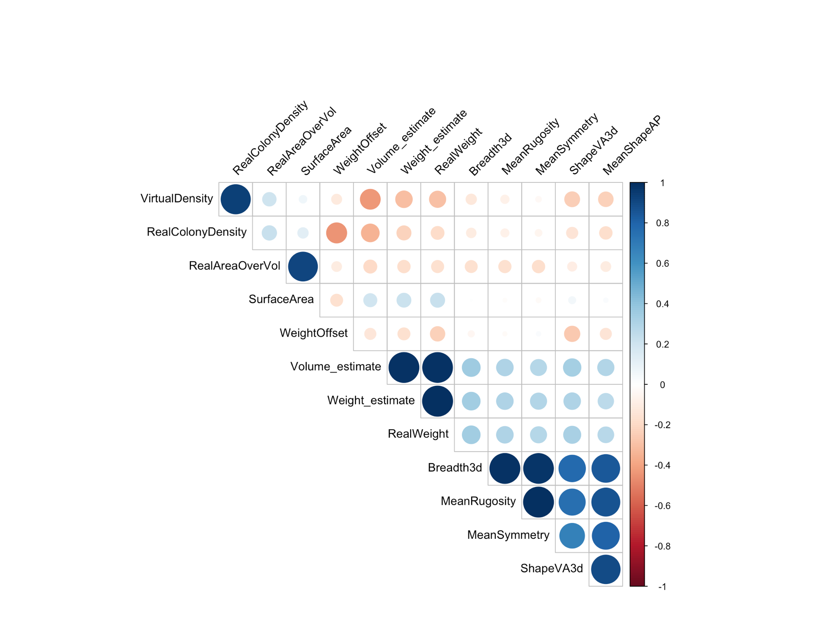



We can propose the following model set up with fixed as well as random effects coming from Coral itself

RealDensity ~ VirtualDensity + WeightOffset + VolumeEstimate + ShapeVA3d + (1|CoralAlias)